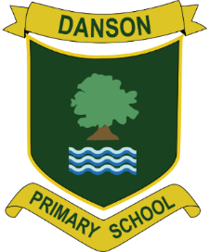

***Nurture-Believe-Inspire-Achieve***

Danson Primary School Curriculum Vision and Intent

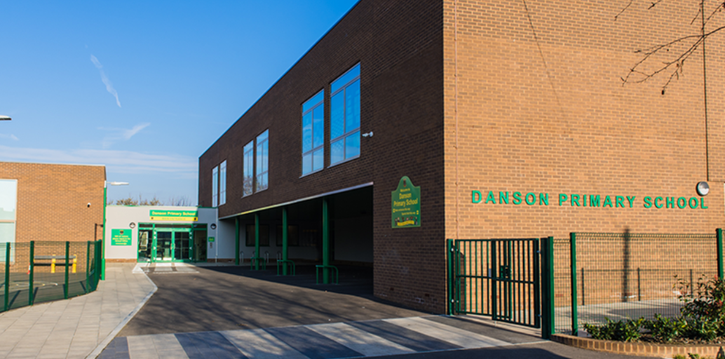

https://lh4.googleusercontent.com/mSk7dN96t5n7avZFu-xhnSzX16vfIEyVZsb54nuGdmb4D2s2MZxTeJnk2WrZU1hfaKQk7ocH3j-kDHhsTi2YVDviaQwiUlmQzFC1YCnSj8lUyKO_5mBFqHHSgUEbhA

**Welcome to Danson Primary School**

At Danson, we work together with our staff, parents and carers, young learners, governors and community members to create a school which aims to be responsive to the needs of our learners.  We do this by providing a safe, caring and friendly atmosphere, where quality and excellence in all things is encouraged and acknowledged.

We are extremely fortunate to have a team of dedicated, hardworking and committed staff who strive to continuously demonstrate our school’s aims and values.  We strive to work together, collaboratively and in partnership both within and outside our Local Authority.  The teaching staff team deliver exciting approaches to learning and teaching ensuring our pupils have a broad and balanced range of opportunities by which to foster the development of positive, responsible attitudes towards learning alongside the development of personal and social skills.

My staff and I are committed to providing a stimulating curriculum so that children are curious and interested in learning. Our aim is to ensure that every child works to the very best of their ability every day so that s/he leaves with the highest standard of attainment possible. This applies across all areas of the curriculum, whether academic, in sport, creativity and social and cultural education. Our extensive tracking systems ensure that progress is measured against individual challenging targets in English, Maths and Science.

At Danson there is an expectation of high academic achievement, we encourage creativity and cater to a personalised approach to learning.  We are committed to ensuring our young people are well prepared for the next stage of their education when they leave us.  We are very proud of our School and of all of our achievements so far.

**Danson Vision**

At Danson our pupils strive to respect the rights of the whole child and others, aspire for both personal and academic success , aim for excellence and achieve our full potential.  Our Vision is for Danson to be an excellent school, where outstanding practice, equality and wellbeing are at the heart of all we do.

**Danson Mission Statement**

At Danson we are committed to ensuring all children who attend our school are

***‘Nurtured, believed in, are inspired and achieve*.’**

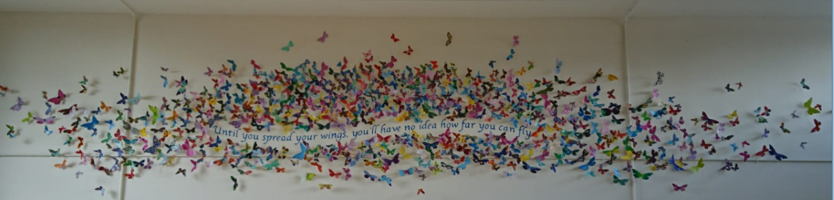

***‘Until you spread your wings you have no idea how far you can fly.’***

*(Our whole school motivational quote which encapsulates our whole school butterfly installation in the assembly hall)*

Our pupils have a plethora of experiences from a broad and balanced curriculum which shapes and develops them as confident, responsible, active and adaptable  and independent learners.  Through Danson’s core values we are unswerving in our desire for all our pupils being committed members of our school community, working in partnership with our parents so that all pupils are the best versions of themselves, reach their potential and are proud of themselves and their achievements.  Every Danson Primary pupil will be prepared for full participation in the local, national and global community to enable them to make a positive contribution now and in the future.

**Danson Values**

-To make our school community a safe and happy place for **ALL**, children and adults, so that each child can learn and achieve to the best of their ability.

-At Danson Primary School we believe that every child has the right to learn, but no child has the right to disrupt the learning of others.

-To help each child develop an understanding of the need to care for others, the importance of ***kindness***, ***empathy***, ***honesty***, **gratitude**, ***tolerance*** including ***perseverance*** where appropriate.

-To help each child respect others and form good relationships with them. In particular, to appreciate the various social and cultural backgrounds within our school community.

-To help each child to respect their own and other’s work or property, both in and outside of school.

**Growth Mindset**

At Danson we share and instil in our pupils the importance of having self-belief and remind them that they can do anything if they put their minds and effort to it.  We want our pupils raised in stimulating environments with growth mindset messages reminding them they are capable of anything!

We believe in the power of having a growth mindset, the importance of brain plasticity and the power of ‘YET’.  We recognise the importance of pupils developing a growth mindset.  It enables them to keep going even when work is hard, they are persistent and show true **grit and effort** towards their learning.

At Danson we recognise the importance of mistakes when learning and that these should be celebrated.  We understand and value that through mistakes in conceptual learning in helps our brains to spark and grow.  We recognise the importance of our brains being challenged and the enjoyment we receive when solving problems.

**National Curriculum Intent**

The School has a statutory responsibility to teach the subjects of the National Curriculum. These are divided in to the Core subjects:

**English, Mathematics, Science, Computing**

And Foundation subjects:

**Art, Design Technology, Geography, History, Music, Physical Education, MFL**

English, Maths and GaPS (Grammar, Punctuation and Spelling) are taught every morning, and Science on specific afternoons. In addition, the Creative Curriculum is timetabled on one or two afternoons through a variety of cross-curricular themes within the overall topic/themed lessons. The organisation of the topics ensures continuity and progression, and skills are assessed termly.

Danson has a broad, balanced and inclusive curriculum that is coherently planned and sequenced to ensure progression of knowledge, skills and understanding across the school. We have an enquiry-based curriculum that encourages the children to ask questions that lead to a deeper level of thinking. Challenging, thought-provoking and engaging activities are facilitated by the teacher to stimulate the children and build on their prior knowledge.

The cross-curricular nature of our lessons enables the children to make connections across different areas of learning. The fluid weaving together of subjects enables creativity to be at the heart of our curriculum. The overarching question that drives the topic allows for all learning to be meaningful and purposeful, building progressively over time.

In effect, English and Maths are practised in real situations. We believe that learning needs to be purposeful, and opportunities to apply knowledge and understanding is a strong foundation on which to consolidate and extend learning. First-hand experience is important and the opportunities to use skills in tackling practical problems and open-ended investigations is a theme, which starts in the Foundation Stage through to the end of Key Stage 2 and in preparation for secondary school.

Our curriculum is enriched by immersive and cultural experiences that build the character of each individual child. We make certain to reflect the diversity of our local community by providing our children with opportunities that they may otherwise not receive at home. Underpinned by the Schools values, they grow in compassion and empathy through charitable giving and awareness of events across the world. We aim for them to become independent, resilient and responsible citizens who can positively contribute to society.

**Our Mission is clear:** Children at Danson will be nurtured, believed in, inspired and will achieve through the high-quality teaching of our ambitious curriculum. Every child at Danson can achieve their full potential and become well-rounded individuals, ready for the next stage of their education. Our vision for each subject area is personalised to ensure specificity.

|  |  |  |
| --- | --- | --- |
| **Curriculum Intent** | | |
| **English (Reading)**  To encourage children to become enthusiastic and critical readers of all forms of the printed word, both fiction and non-fiction, being encouraged to interact with the text analytically and thereby, hopefully, establishing a lifelong interest in reading, writing and debate. | **English (Writing)**  To enable our children to express themselves creatively and imaginatively and to communicate with others effectively. | **Maths**  For children to master the mathematical skills of fluency, reasoning and problem solving to gain the skills to be systematic and resilient thinkers and to be equipped with valuable life skills. |
| **Religious Education**  To prepare children to be part of a community in which they develop their understanding of different faiths and religions. | **Science**  To embolden children to think, act and grow as scientists in line with their own inquisitive nature; in order to provide them the opportunity to understand, question and change the ever changing world they will grow to live in. | **Art and Design**  To develop artistic skills and encourage children to express their creativity and individuality, inspired by their own and others’ cultures. |
| **Computing**   To develop skills necessary to become digitally literate and to communicate safely and to collaborate and create digital content. | **Design and Technology**  To develop innovation, creativity and problem solving through an understanding of designs and their impact on daily life. | **Geography**   As a multicultural school, we want the children to develop a mutual respect of all cultures, as well as learn key physical and human geographical features of the world. |
| **History**  We encourage the children to develop the skills of enquiry and analysis to understand how the world in which they live has developed over time. | **Languages**  To develop basic language learning skills, knowledge and vocabulary for global communication. | **Music**  For children to grow in creativity and express themselves musically |
| **Physical Education**  We aim for our children to develop their physical skills through practise and building of sporting values to develop a lifelong love for physical activity and healthy lifestyle to equip them for their futures. | **PSHE**  For the children to become good, well-rounded citizens who are informed, educated and confident, and can build healthy relationships with others. | **Early Years**  To provide the foundation blocks of lifelong learning and grow a love for learning to develop through life. |
| **SMSC**  SMSC is the spiritual, moral, social and cultural development of our children. At Danson we believe that these areas are intrinsic to the daily life of the school, as well as promoting the Danson and British Values. We aim to develop and nurture these through our everyday teaching to create well-rounded, empathetic individuals. At Danson, we explore beliefs and feelings whilst giving children opportunities to reflect on themselves and their learning throughout their daily lives.  Danson teaches the children to have a good understanding of what is right and wrong as well opportunities to discuss moral and ethical issues. Pupils develop and hone their social skills in order to apply them in a wide range of situations. Pupils have the opportunities to experience and understand different cultures and develop an awareness of the different cultures that make up the UK.  SMSC is threaded throughout a relevant, broad and balanced curriculum at Danson. | | |

**Opportunities for deeper and immersive learning at Danson**

At Danson we are delighted to host immersive whole school themed weeks to promote and encourage deeper learning. Examples of these across the year include:

* Maths week
* Science week
* Book week
* Sports week
* Creative Curriculum week
* Financial Awareness week
* Safer Internet Week
* Curricular themed trips
* Curricular themed visitors to school

**Danson Primary School EYFS Curriculum Intent**

The Early Years Foundation Stage Curriculum at Danson Primary is based on Statutory Framework for the EYFS which applies to children from birth to the end of the reception year and aims to ensure that ‘all children learn and develop well and are kept healthy and safe’ (Department for Education). We follow the outlines of the Development Matters, a non-statutory guidance material which supports practitioners in implementing the statutory requirements of the EYFS.

The EYFS Curriculum is underpinned by four overarching principles:

·         A Unique Child

·         Positive Relationships

·         Enabling Environments

·         Learning and Development

**The Unique Child**

At Danson Primary recognise that every child is unique. Every child is constantly learning and can be resilient, capable, confident and self-assured. We understand that children develop in different ways and at different rates. Children’s attitudes and dispositions to learning are influenced by feedback from others; we use praise and encouragement, as well as celebration/sharing assemblies and rewards, to encourage children to develop a positive attitude to learning. All children and their families are valued at Danson Primary School. Children are treated as individuals and have equal access to all provisions available. All children are encouraged to achieve their personal best and planning is adapted to meet the needs of all groups and abilities. Assessments take into account contributions from a range of perspectives to ensure that any child with potential special educational needs is identified at the earliest possible opportunity. Early identification of special needs is crucial to enable staff to support the development of each child. Concerns are always discussed with parents/carers at an early stage and the school’s SENCO is called upon for further information and advice.

**Positive Relationships**

At Danson Primary we recognise that children learn to be strong and independent from secure relationships. We aim to develop caring, respectful, professional relationships with the children and their families. We recognise that parents are children’s first and most enduring educators and we value the contribution they make. We recognise the role that parents have played, and their future role, in educating the children.

**Enabling Environments**

At Danson Primary we recognise that the environment plays a key role in supporting and extending the children’s development, where the children feel confident, secure and challenged. The children have daily access to an indoor and outdoor environment that is set up in discrete areas of learning with planned continuous provision. Play-based learning is paramount and children have opportunities to direct their own learning with planned opportunities provided by staff. We plan a learning environment, both indoors and outdoors, that encourages a positive attitude to learning and reflects the individual’s interests, passions and abilities. We use materials and equipment that reflect both the community that the children come from and the wider world. We encourage the children to make their own selection of the activities on offer, as we believe that this encourages independent learning. We ensure that resources and spaces are safe to use and checked regularly.

**Learning and Developing**

The EYFS Curriculum – Danson Primary curriculum for the Foundation Stage reflects the areas of learning identified in the Early Learning Goals.

There are seven areas of learning and development of which three are “prime areas” and four are “specific areas.” The areas overlap and cannot be delivered in isolation for others. None of the areas of learning can be delivered in isolation from the others. At Danson Primary we ensure we provide a wide range of learning experiences to enable all children to develop competency and skill across all learning areas.

The three **prime areas** are:

· Personal, Social and Emotional Development

· Communication and Language

· Physical Development

 The **specific areas** are:

· Literacy

· Mathematics

· Understanding the World

· Expressive Arts and Design

 At Danson Primary children’s development levels are regularly assessed through observations, including information provided by parents and other settings and formal assessments. The balance will shift towards a more equal focus on all areas of learning as children grow in confidence and ability within the three prime areas. However, if a child’s progress in any prime area gives cause for concern, staff will discuss this with the child’s parents and/or carers and agree how to support the child.

Experiences and activities planned at Danson Primary will reflect the different ways that children learn. We support children in using the three characteristics of effective learning which are:

* Playing and Exploring - children investigate and experience things, and ‘have a go’.
* Active Learning - children concentrate and keep on trying if they encounter difficulties and enjoy achievements.
* Creating and Thinking Critically - children have and develop their own ideas, make links between ideas, and develop strategies for doing things. (Statutory Framework for EYFS 2021).

**EYFS Curriculum**

**Yearly Overview**

The staff plan to deliver a broad and balanced curriculum that encompasses all aspects of the Development Matters document across the year, based on the observations of children’s play and what their interests are. This appears in the weekly enhancements to the continuous provision, as well as in the adult-led focuses and group-time work. There are also opportunities to explore a variety of topics of work, including those suggested by the children.

**Mark making/Funky Fingers**

The children will be given a range of mark-making tools to experiment with both inside and outside. They will engage in activities to strengthen the muscles in their arms, hands and fingers that they will need to use to write, including: playdough, tweezers, threading. This will prepare your child to form numbers and letters in the cursive style.

**Phonics/Early Reading**

At Danson we follow Read Write Inc scheme. Sounds are taught in a particular order so that children can begin to read VC (vowel/consonant) and CVC (consonant/ vowel/consonant) as soon as possible and experience success. The learning is delivered in a fun, game-based manner. Children are taught to blend sounds in words to read to enable them to become more independent when reading words and sentences.

o   Read Write Inc Bookbag Books which offer fully decodable books, aligned withRWI programme to support, independent, shared and whole-class reading.

**Early Writing**

At Danson Primary we encourage mark making and early writing in a variety of ways. Children are taught how to form letters correctly as soon as a new sound is introduced and mark making is modelled daily. Opportunities for purposeful writing are provided daily in adult-led tasks and through the continuous provision. Children are taught to segment sounds to write words and simple sentences using their phonics skills as well as to spell some irregular common word. Emergent writing is promoted in all areas of learning in EYFS.

**Maths**

At Danson Primary we follow Maths Mastery Curriculum aiming to enable children to acquire a deep, long-term, secure and adaptable understanding of the subject. We use a variety of practical activities and games to develop children’s ability to recognise numbers, shapes, measures and patterns, and to apply this understanding in a variety of contexts.

 o Numbots – at Danson Primary children have access to Numbots online platform supporting understanding, recall and fluency in mental addition and subtraction.

**Home Learning**

At Danson Primary we believe Home Learning is an essential part of every child’s education. It helps to reinforce and consolidate skills and knowledge that they have covered in school. Home learning tasks will be set weekly via Google Classroom.