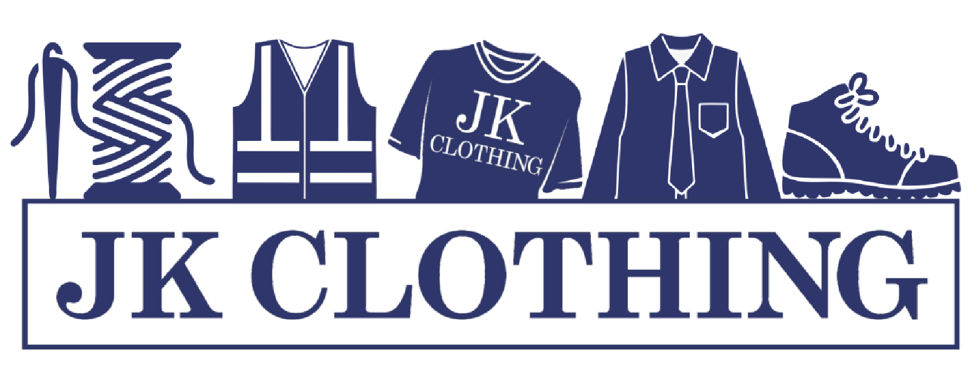


14 Wellington Parade, Blackfen,
Sidcup, DA15 9NB
020 8303 3136

DANSON PRIMARY SCHOOL 2024

www.jkclothing.co.uk
UNIFORM PRICE LIST

Prices From
School sweatshirt with logo +£2 adult sizes £11.50

School polo shirt with logo +£2.50 adult sizes £7.00

School cardigan with logo +£2 adult sizes £12.99
¼ zip pe jumper £19.99

Reversible waterproof coat with logo £19.99

White PE t-shirt with logo £6.00

Woolly hats with logo £6.00

Bottle Green PE shorts £6.00

Black plimsolls £6.99

Boys grey trousers £9.99

Boys grey school shorts £9.99

Girl’s Bottle green skirts £9.99

Bottle green Fleece jacket with logo £14.99

Bottle green pinafore dresses £19.99
Jogging bottoms bottle green £11.99
School baseball cap £6.00

PE bags £5.00

Book bags £7.50
Iron in name labels 12 for £2.50 24 for £4.00

Open 9am till 5pm Monday to Saturday

